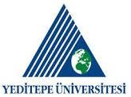
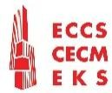
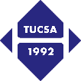
SECOND ANNOUNCEMENT AND CALL FOR PAPERS

INTERNATIONAL CONFERENCE & WORKSHOP ON
SEISMIC DESIGN OF STEEL STRUCTURES AND RETROFIT
For Resilient Future
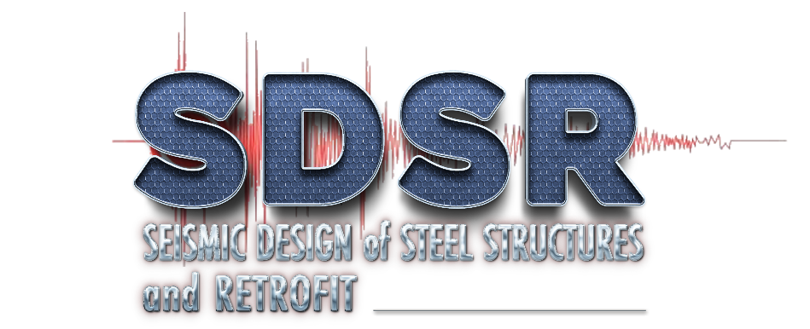
and
13TH EUROPEAN STEEL DESIGN AWARDS CEREMONY
16-17 October 2025

Organised by
Turkish Constructional Steelwork Association (TUCSA)
in coordination with European Convention for Constructional Steelwork (ECCS)
Hosted by Co-Organiser Yeditepe University (YU)

Dear colleagues,
It is our great pleasure to invite you to the International Conference and Workshop on Seismic Design of Steel Structures and Retrofit for Resilient Future to be held on 16-17 October 2025 in Istanbul. The theme of the conferences is based on the resilience and adaptability framework of the European Union in seismic regions.
The workshop aims to discuss readiness of earthquake zones for the expected seismic activities in the future. During the conference, various topics related to the seismic design of steel structures and retrofit will be presented by researchers, academics and experts.
The annual meetings of the European Convention for Constructional Steelwork (ECCS) will also take place for members of the ECCS, which will be followed by the conferences and workshop on seismic design of steel structures and retrofit, as well as the activities listed in the following schedule:
14-15 October 2025 ECCS Annual General Meetings (Members only)
14 October 2025 Presidents & Directors Dinner (Members only)
15 October 2025 European Steel Design Awards (ESDA 2025) (for all participants)
15 October 2025 Gala Dinner and 70th Anniversary of ECCS (for all participants)
16 October 2025 TC13 Seismic Design Technical Committee Meeting (Members only) at Yeditepe University (YU)
16 October 2025 Workshop (YU)
17 October 2025 Conference (YU)
As stated at the Background and Scope section below, the city of Istanbul is one of the best places to organise the earthquake conference, located between Europe and Asia on both sides of the Bosphorus, where very important earthquakes have occurred in her history dating back to prehistoric times around Golden Horn, Khalkedon, Bathonea etc.
For more information and registration, please visit: https://sdsr.tucsaevents.org/index.html
We sincerely hope you will join us on 14-17 October 2025 in Istanbul.

H. Yener GÜR’EŞ  Organising Committee Chair  President of TUCSA | Dr. Özgür KÖYLÜOĞLU  Yeditepe University  Head of Civil Engineering Department

TOPICS AND KEY DATES
The Conference covers the various topics under the following titles as shown at the website:
- Seismic Design of Conventional Steel Structures
- Seismic Design of Cold-formed Steel Structures
- Seismic Design of Composite Structures
- Technologies for Seismic Design and Monitoring
- Retrofit, Strengthening and Post-disaster Assessment of Steel and Composite Structures
- Architectural Design with Steel Structure
- Safety, Serviceability and Maintenance Issues for Steel Structures
The workshop will discuss the topics in groups, each covering the following areas in detail as shown at the website:
Group-1: Regulations, Permitting and Responsibility
Group-2: Disaster Preparedness and Response
Group-3: Post Earthquake Evaluation and Repair Criteria for Steel Structures
Group-4: Retrofitting of Existing Structures
Group-5: Seismic Design Principles for Steel Residential & Commercial Buildings and Steel Industrial and Infrastructural Structures
Group-6: Tools and Technologies for Safety, Serviceability and Monitoring

KEY DATES

21 July 2025 Deadline for Submission of Abstracts
28 July 2025 Notification of Acceptance to Authors
1 September 2025 Deadline for Submission of Full Papers
15 September 2025 Final Acceptance
16-17 October 2025 Workshop & Conference

REGISTRATION FEES AND OPTIONALS

MAIN EVENTS
DATES | ITEMS FOR REGISTRATION | REGULAR PRICE
16-17 October 2025 | Workshop & Conference ⁽¹⁾ | € 200
14-15 October 2025 | ECCS Meetings ⁽²⁾  (Only for ECCS members) | € 210
14-17 October 2025 | ECCS Meetings + Symposium ⁽³⁾  (Only for ECCS members) | € 390
International wire transfer expenses |  | € 22

OPTONALS
DATES | ITEMS FOR REGISTRATION | REGULAR PRICE
14 October 2025 | Presidents & Directors Dinner  (Only for ECCS members) | € 90
15 October 2025 | Gala Dinner  (for all participants) | € 120
16 October 2025 | ESBA 2025 Awards Ceremony at Yeditepe University ⁽⁴⁾ | Free of charge
 | Accompanying Persons ⁽⁵⁾  (for two days) | € 200
 | Proceedings (Printed copy) | € 25
 | Submission of the second paper | € 40
Notes:
(1) Covers admission to the workshop & conference sessions, including a full paper presentation, digital proceedings, coffee breaks, lunches at Yeditepe University for two days,
(2) Covers admission to the ECCS annual meeting sessions (TMB, PMB, EB and GA), coffee breaks and lunches at Istanbul Marriott Hotel Asia for two days.
(3) Covers admission to the symposium and ECCS annual meeting sessions (TMB, PMB, EB and GA), a full paper presentation, digital proceedings, coffee breaks, lunches for four days,
(4) Participation in the European Steel Design Awards Ceremony is free of charge, but registration is required.
(5) Sightseeing in Istanbul with guide covering lunches and museum visits for two days. It may be realised should enough participation be provided.
(6) Bank accounts for above fees are:
For Transfer in Euro
Beneficiary: TÜRK YAPISAL ÇELİK DERNEĞİ
Bank / Branch: GARANTİ BBVA / Acıbadem
Account No: 404 - 9094719
IBAN: TR68 0006 2000 4040 0009 0947 19
Swift: TGBATRISXXX
For Transfer in TRL
Beneficiary: YAPISAL ÇELİK EĞİTİM ARAŞTIRMA MERKEZİ
Bank / Branch: GARANTİ BBVA / Acıbadem
Account No: 404 - 6299347
IBAN: TR91 0006 2000 4040 0006 2993 47
(7) Participants from Turkey may pay in Turkish Lira according to the current rate provided by the organisation desk.

