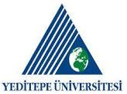
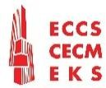
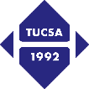
INTERNATIONAL CONFERENCE & WORKSHOP ON
SEISMIC DESIGN OF STEEL STRUCTURES AND RETROFIT
For Resilient Future
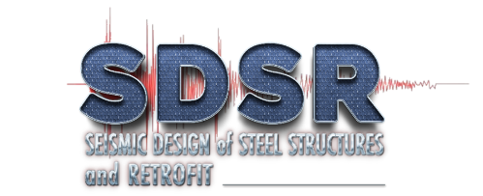

PROGRAM
14 October 2025, Tuesday, Istanbul Marriott Hotel Asia
13:30-17:00 ECCS TMB Meeting (Members only)
15 October 2025, Wednesday, Istanbul Marriott Hotel Asia
09:00-12:30 ECCS PMB Meeting (Members only)
12:30-13:30 Lunch break
13:30-17:00 ECCS TMB-PMB Joint Meeting (Members only)
19:30 ECCS Presidents & Directors Dinner
16 October 2025, Thursday, Yeditepe University
09:00-10:15 ECCS TC13 Seismic Design Technical Committee Meeting (Members only)
09:00-13:00 ECCS Executive Board (EB) & Annual General Meeting (AGM) (Members only)
13.00-14:00 Lunch break
09:30-10:15 Registration for Workshop
10:15-10:45 Opening Remarks & Description of workshop procedure
10:45-13:15 Workshop (Group works)
Group-1: Regulations, Licensing and Responsibility
Group-2: Structural steel solution alternatives, advantages, and challenges for new structures (residential, commercial, public structures, and infrastructures)
Group-3: Post-Earthquake Damage Assessment and Repair Criteria and Applications for Steel Structures
Group-4: Steel Solutions for Retrofitting of Existing Structures
Group-5: Solution Technologies for New Structures and Strengthening (Seismic isolators, buckling restrained braces (BRB), fire safety, corrosion, monitoring, etc.)
13.15-13:45 Quick lunch break (in place)
13:45-14:45 Workshop (Group works)
14:45-16:00 Workshop (Plenary session)
16:00-16:30 Coffee break
16:30-18:00 13th European Steel Design Awards (ESDA 2025)
(Travel from the university to the hotel from hotel to dinner + desk is required)
19:30 Gala Dinner and 70th Anniversary of ECCS
17 October 2025, Friday, Yeditepe University
08:30-09:00 Registration
09:00-09:30 Opening Remarks
09:30-10:30 Session-1 Key-note Speakers (Moderator: Dr. Özgür KÖYLÜOĞLU)
09:30-10:00 Steel Moment-Resisting Frame Structures in Seismic Regions: bridging Research and Codes
Prof. Dr. R. LANDOLFO, University of Naples Federico II, Italy
10:00-10:30 Redefining Seismic Resilience in Cold-Formed Steel: Insights from the CFS-NHERI Program and CFS10 Testing, (B.W. Schafer and T.C. Hutchinson)
Prof. Dr. B. SCHAFER, John Hopkins University Whiting School of Engineering, USA
10:30-10:45 Coffee break

10:45-11:45 Session-2 Paper and case study presentations (Moderator: TBD)
Presenters and title of presentations will be given soon
11:45-12:00 Coffee break
12:00-13:00 Session-3 Paper and case study presentations (Moderator: TBD)
Presenters and title of presentations will be given soon
13.00-13:45 Lunch break
13:45-14:45 Session-4 Key-note Speakers (Moderator: TBD)
13:45-14:15 Collective Mind Antakya- Civil Initiative
Prof. Dr. Ece CEYLAN BABA – Architect Şerif SÜVEYDAN, Türkiye
14:15-14:45 Data Driven Techniques in Seismic Design and Assessment
Doç. Dr. Alper KANYILMAZ, Politecnico di Milano, Italy
14:45-15:00 Coffee break
15:00-16:00 Session-5 Paper and case study presentations (Moderator: TBD)
Presenters and title of presentations will be given soon
16:00-16:15 Coffee break
16:15-17:15 Session-6 Paper and case study presentations (Moderator: TBD)
Presenters and title of presentations will be given soon
17:15-17:20 Closing Remarks
H. Yener Gür’eş, President of TUCSA

